# CONSIDER MAKING A DONATION SO I CAN SHARE MORE CONTENT

With your donations I pay several subscriptions to magazines and books websites, that's how I can share so many books and magazines.

You can help me keep sharing every day by making a donation via PayPal:

**PayPal Link:**

<https://www.paypal.com/donate?hosted_button_id=3GZSQKCJHVXDW>

**PayPal QR Code:**

[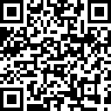](https://www.paypal.com/donate?hosted_button_id=3GZSQKCJHVXDW)